**Day 8**

1. Create view vw_updatable_products (use same query whatever I used in the training)

Try updating view with below query and see if the product table also gets updated.

Update query:

UPDATE updatable_products SET unit_price = unit_price * 1.1 WHERE units_in_stock < 10;

**Query:**

CREATE OR REPLACE VIEW VW_UPDATABLE_PRODUCTS AS

SELECT

PRODUCT_ID,

PRODUCT_NAME,

UNIT_PRICE,

UNITS_IN_STOCK,

DISCONTINUED

FROM

PRODUCTS

WHERE

DISCONTINUED = 0

WITH

CHECK OPTION;

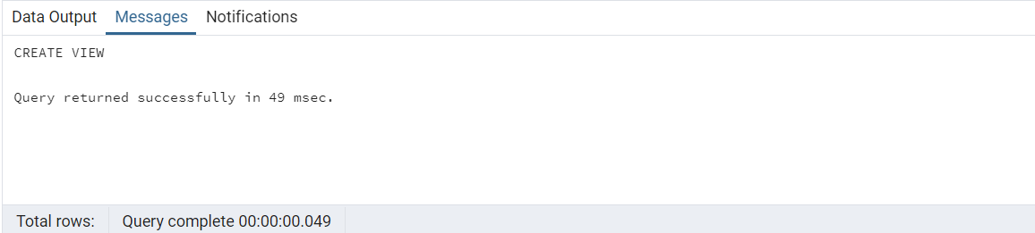

**Output:**

-- query to check before udpateing view

SELECT

PRODUCT_ID,

PRODUCT_NAME,

UNIT_PRICE,

UNITS_IN_STOCK,

DISCONTINUED

FROM

VW_UPDATABLE_PRODUCTS

WHERE

UNITS_IN_STOCK < 10;

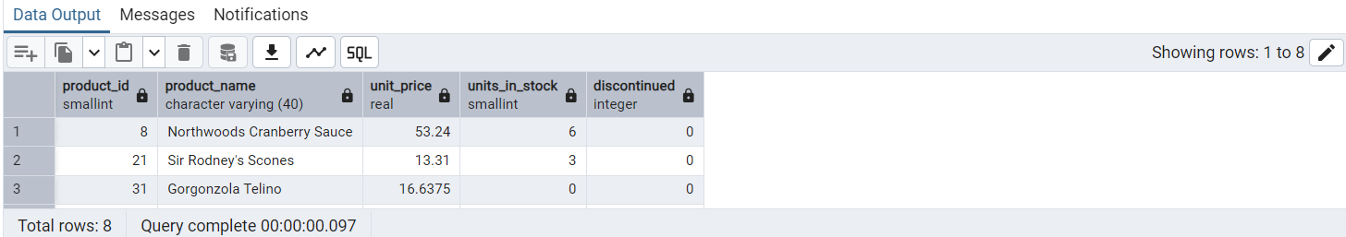

UPDATE VW_UPDATABLE_PRODUCTS

SET

UNIT_PRICE = UNIT_PRICE * 1.1

WHERE

UNITS_IN_STOCK < 10;

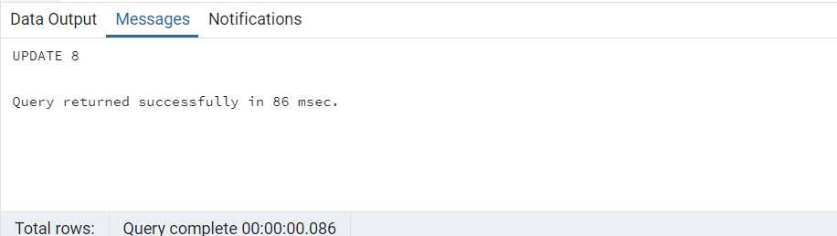

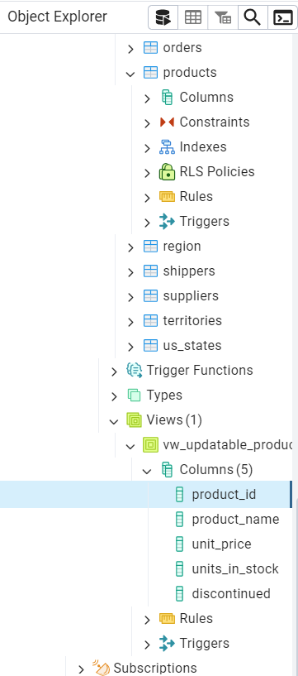

2. Transaction:

Update the product price for products by 10% in category id=1

Try COMMIT and ROLLBACK and observe what happens.

**Query:**

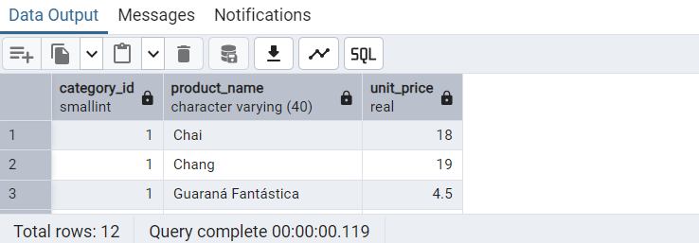

begin;

update products set unit_price = unit_price * 1.10 where category_id =1;

do $$

begin

if exists (select 1 from products where category_id=1 and unit_price >50)

then raise notice 'Some unit prices are >50';

else raise notice 'Updated products unitprice';

end if;

end$$;

commit;

rollback;

**Output:**

select category_id,product_name,unit_price from products where category_id=1;

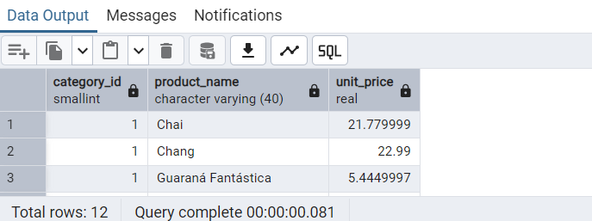

3. Create a regular view which will have below details (Need to do joins):

Employee_id,

Employee_full_name,

Title,

Territory_id,

territory_description,

region_description

**Query:**

CREATE OR REPLACE VIEW VW_EMPLOYEE_TERRITORY_REGION AS

SELECT

E.EMPLOYEE_ID,

FIRST_NAME || ' ' || LAST_NAME AS EMPLOYEE_FULL_NAME,

TITLE,

T.TERRITORY_ID,

TERRITORY_DESCRIPTION,

R.REGION_DESCRIPTION

FROM

EMPLOYEES E

JOIN EMPLOYEE_TERRITORIES ET ON E.EMPLOYEE_ID = ET.EMPLOYEE_ID

JOIN TERRITORIES T ON T.TERRITORY_ID = ET.TERRITORY_ID

JOIN REGION R ON R.REGION_ID = T.REGION_ID;

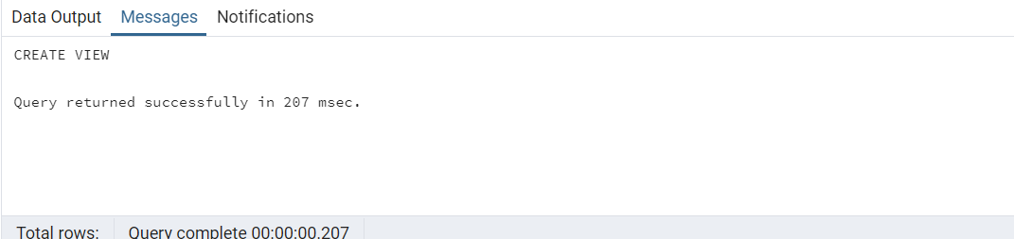

**Output:**

SELECT * FROM VW_EMPLOYEE_TERRITORY_REGION;

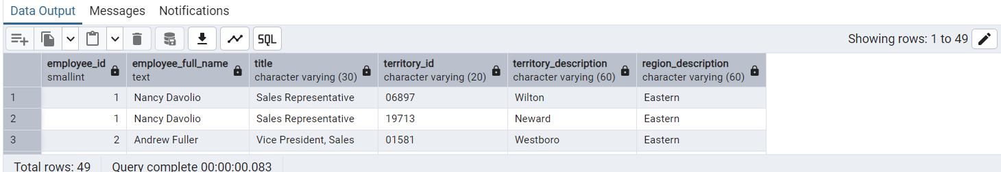

4. Create a recursive CTE based on Employee Hierarchy

**Query:**

WITH RECURSIVE RCTE_EMPLOYEE AS (

SELECT

EMPLOYEE_ID,

FIRST_NAME,

LAST_NAME,

TITLE,

REPORTS_TO

FROM

EMPLOYEES

WHERE

REPORTS_TO IS NULL

UNION

SELECT

E.EMPLOYEE_ID,

E.FIRST_NAME,

E.LAST_NAME,

E.TITLE,

E.REPORTS_TO

FROM

EMPLOYEES E

JOIN RCTE_EMPLOYEE RE ON E.REPORTS_TO = RE.EMPLOYEE_ID

)

SELECT

EMPLOYEE_ID,

FIRST_NAME,

LAST_NAME,

TITLE,

REPORTS_TO

FROM RCTE_EMPLOYEE;

**Output:**

